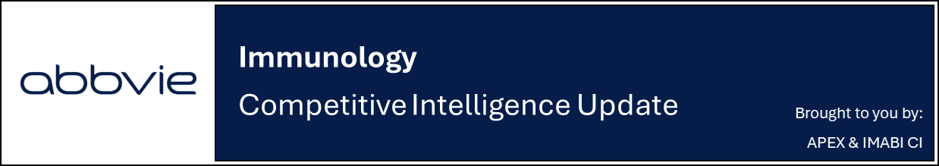

Lilly reports positive Phase 3 topline results for Ebglyss in pediatric moderate-to severe AD; plans regulatory submissions for label expansion

Company: Eli Lilly  Drug: Ebglyss (lebrikizumab, SC IL-13 inhibitor) | Date: March 16, 2026  Source(s): Press Release

What happened:
- Lilly announced positive topline results from the Phase 3 ADorable-1 trial evaluating Ebglyss in pediatric patients aged six months to <18 years with moderate-to-severe AD
- Both co-primary endpoints met at Week 16, demonstrating meaningful improvements vs placebo in disease severity and skin clearance (EASI-75: 63% vs 22%; IGA 0/1: 44% vs 15%)
- Ebglyss showed a safety profile consistent with previous adult and adolescent studies, with no new safety signals identified
- Lilly plans to submit these data to US and global regulators to support a potential label expansion of Ebglyss in younger pediatric populations
  - Additional results from ADorable-1 and the 52-week extension study ADorable-2 are expected later in 2026

Impact (CI PoV): HIGH
- Positive Phase 3 results support lifecycle expansion for Ebglyss into younger pediatric AD populations, extending the product beyond its current approval in patients ≥12 years old, and enabling Lilly to compete across the full age spectrum of moderate-to-severe AD
- CI estimates approval of Ebglyss in younger pediatric AD patients in Q1 2027 US/EU, assuming imminent submission
  - Recall, Ebglyss is currently approved in the EU (November 2023), Japan, Canada (January 2024), and the US (September 2024) for moderate-to-severe AD for adults and children ≥12 yrs

Why it matters (CI Insights in blue italics):
- Pediatric expansion would position Ebglyss to in younger populations, where Dupixent currently has the most established presence across age groups (approved for 6 months and older AD patients in the US and EU)
  - "Despite the high prevalence of moderate-to-severe AD in infants and young children, they have fewer approved treatment options than adults and adolescents," said Amy Paller, M.D., chair, department of dermatology at Northwestern University and ADorable study investigator
- The data further reinforces IL-13 inhibition as a validated mechanism in AD, supporting ongoing competition within the IL-4/IL-13 pathway-targeting biologics class

Tell me more:
- Study design: Randomized, double-blind, placebo-controlled ADorable-1 Phase 3 trial evaluating Ebglyss in pediatric patients (6 months-18 years) with moderate-to-severe AD
  - Topical corticosteroids (TCS) were required beginning 2 weeks before randomization and throughout the 16-week study, with the option to decrease/stop after achieving IGA ≤2
- Dosing: Participants were randomized to placebo or weight-based Ebglyss dosing, administered as a loading dose and then subsequent doses by subcutaneous injections with a topical TCS (dose not disclosed)
- Efficacy outcomes: Ebglyss showed improvements in disease severity and itch vs placebo across primary and key secondary endpoints at Week 16:
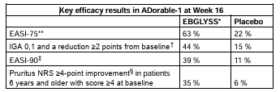
- Safety: Safety and tolerability profile consistent with previous adult and adolescent studies
  - Most common AEs (≥5%) were upper respiratory tract infections and nasopharyngitis, with similar frequencies across treatment groups
  - Injection-site reactions occurred at comparable rates in both arms, with no injection-site pain reported
- Next milestones: Additional data from ADorable-1 and ADorable-2, the 52-week extension study following ADorable-1 participants are expected to be released later this year (timelines undisclosed; note that no AAD 2026 abstracts include these data)

For questions, please reach out to:
 | Dermatology | Rheumatology | Gastroenterology
APEX (US/PCS) | Chanda Bhat | Bethany Christmann | Luke Versten
IMABI (International/ Affiliates) | Priti Anand | Irene Knorn | Priti Anand

Invite your colleagues to inVision | Manage Email Preferences | Unsubscribe

This document contains competitive intelligence collected via AbbVie approved methods or vendors. We collect competitive intelligence consistent with industry standards and AbbVie policy. Not for commercial field use. Please reach out to CI, Legal or OEC with any questions.

